## Installation of Agilent 415X LabVIEW software

1. NOTE: This procedure is used when installing the LabVIEW software in a new PC. The process was found [here](https://forums.ni.com/t5/Instrument-Control-GPIB-Serial/Old-visa-open-error-code-1073807343-using-VISA-with-a-GPIB/td-p/3103032?profile.language=en).
2. Install LabVIEW (it does not have to be a 32-bit version).
   1. NOTE: LabVIEW needs to be installed BEFORE the Keysight Connection Expert.
3. Copy the 415X LabVIEW vi files into a directory of your choice.
   1. NOTE: There is no need to install a driver for the SPA.
4. Run NI MAX.
5. Go to “Tools” 🡪 “NI-VISA” 🡪 “VISA Options” 🡪 “My system” 🡪 “Passports” 🡪 “List of passports” and enable “NiVisaTulip.dll”. Then click “Save” and close the program.

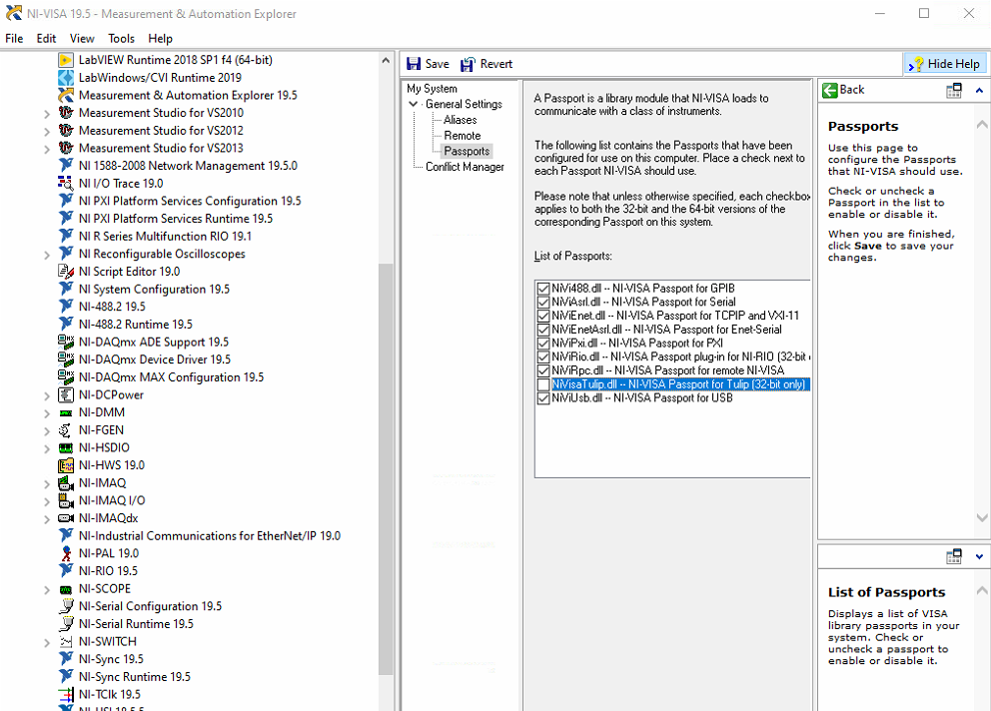

1. Download and install “Keysight Connection Expert”.
   1. NOTE: When prompted about the Keysight VISA drivers, assign them to “secondary, side by side” and not “primary”.
2. Run it and it should immediately recognize the SPA.
   1. Note down the GPIB address of the SPA (e.g. GPIB0::14::INSTR).
3. Click the “Gear” icon 🡪 “Settings” 🡪 “Keysight 488 GPIB Options” 🡪 Tick “Enable Keysight GPIB Cards for 488 Programs”.

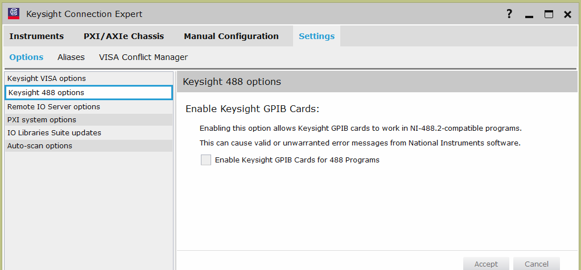

1. Restart the PC.
2. Run LabVIEW and go to “Help” 🡪 “Find examples” 🡪 “Search for GPIB” 🡪 "Simple GPIB.vi". If you enter the number of the GPIB address (14, not the whole GPIB0::14::INSTR), it queries it with *IDN? and it should returns the instrument's info.
3. Restart the PC.
4. The LabVIEW programs should run now, provided that they are configured to the correct GPIB address. Look inside the block diagram (Ctrl+E) of the vi program you intend to run (e.g. of Frontend.vi) to verify this.